Technology, Geography, and Trade (2002)
Jonathan Eaton and Samuel Kortum

Background
- Ricardian trade model
- Framework used to explain why countries trade and what they trade
- Based on differences in productivity across countries
- Origin in comparative advantage: country doesn’t have to have absolute productivity advantage to benefit from producing/trading something, just relative advantage
- Production function usually only has only labour input with a fixed labour requirement per unit of output for each good and country
- Countries differ in productivity not resource endowment
- Constant opportunity cost so ppf is a straight line (i.e., no diminishing returns)
Motivation
- This paper updates the Ricardian trade model; creates a Ricardian model of international trade based on differences in technology and including geography
- It incorporates realistic geographic features into general equilibrium
- Updates classical Ricardian framework to make usable for real-world quantitative analysis
- Modern models might add iceberg costs (to deliver 1 unit must ship more than 1 unit to account for transit costs/tariffs/delays etc.)
- Also consider continuum of goods (not just two); interval [0,1] index to rep infinitely many goods, ranked by how strong one country’s CA is in each
- This produces a smooth function to show which country produces which goods and gets clean aggregate results (price, wage)
- Costs scale with distance so considering common language, if border is shared etc. trade falls sharply with distance (gravity pattern)
- N countries rather than just two
- “GE” means model doesn’t just solve for trade patterns but also wages/prices in every country, labour allocation, where every good is produced/consumed and how this clears every market at once (goods market, trade-balance condition)
- Use model to explore various issues:
- Gains from trade
- Role of trade in spreading the benefits of a new technology
- Effects of tariff reduction
Main Finding
Data
- Parameters are estimated with data on bilateral trade in manufactures, prices, and geography from 19 OECD countries in 1990
- Real trade data (how much country a exports to country b for every pair among 19 rich countries) for one year, manufacturing sector only, and use this to fit parameters
Model
- Ricardian trade model with geographic features incorporated into GE
- Simple structural equations for bilateral trade
- Expressions relate bilateral trade volumes to :
- Deviations from purchasing power parity
- Technology and geographic barriers
- TLDR; this model is a system of equations derived from economic theory
- Productivity is random: each country draws productivity for every good from a Fréchet probability distribution, with country-specific location parameter Tᵢ and common shape parameter θ
- Firms/countries minimize cost
- Consumers choose cheapest source of good
- Aggregating over the continuum of goods (using properties of the Fréchet distribution), you get a clean, closed-form expression for the share of country n's spending that goes to imports from country I gravity equation
- From these two relationships, estimate parameters to solve the world trading equilibrium of the model and examine changes in response to polices
- Equations include parameters relating to:
- Absolute advantage
- Comparative advantage (promoting trade)
- Geographic barriers (resisting it)
- Transport costs
- Tariffs and quotas
- Delay
- Problems with negotiating a deal from afar
- Comparative advantage and geographic barriers are competing forces
- The three parameters being estimated:
- State of technology T_{i} (absolute advantage): how generally productive/efficient a country’s economy is overall
- One number for each country; captures how generally productive country i is (its absolute advantage level)
- Heterogeneity of tech Theta (comparative advantage): spread parameter; governs how much variation there is across goods within a country (i.e., how strong a country’s CA patterns are)
- A single parameter for whole model (not country specific); how much variation there is in comparative advantage across goods within any country
- Low theta means huge variation in relative productivity across goods (strong CA patterns); high theta means goods more similar to each other (weak CA)
- Geographic barriers d_{ni}: trade costs between country pairs (fn of distance, tariffs, borders, etc.)
- Bilateral, one cost parameter for each pair of countries importer n, exporter i
- Value derived from a fn; d is a fn of distance between n,i and indicator if bordering so just estimate some couefficients and use those to apply to every country pair
- Once they have parameter estimates, they simulate the model under hypothetical scenarios and see what changes
- Four scenarios tested:
- Gains from trade: compare real world to autarky and “zero gravity” (no geographic barriers/costs)
- Result: everyone gains from freer trade but smaller countries gain more
- Specialization patterns: as trade costs fall from high levels, manufacturing concentrates initially in large countries (cuz can access cheap intermediaries domestically)
- Keep lowering barriers and eventually small countries catch up
- Technology diffusion by trade: if one country gets better tech that benefits other countries too through trade; size of spillover to other countries depends on how close they are and how easily they can shrink their own manufacturing sector to import more instead (labour flexibility)
- Tariffs: multilateral cuts (everyone cuts tariffs together) tends to help almost everyone; unilateral tariff cuts by the US specifically hurt the US (a big country can sometimes benefit from it cuz market power)
- Build on DFS model of Ricardian trade with a continuum of goods (two country/productivity known for each good)
- Instead of “country A’s productivity in good j is X” this paper says productivity in each good is a random draw from a probability distribution that is specific to each country
- This change matters because:
- With only two countries and deterministic productivities, can rank all goods from “most country A advantage” to “most country B advantage”
- But with 50 countries, ranking every good across every country’s deterministic productivity is hard; no clean ordering
- By treating each country’s productivity draws as RVs from a known distribution, EK can use tools from probability theory (like extreme value theory) to compute things like “the prob that country i has the lowest cost for a given good” even with many countries
- Basically converts combinatorial ranking problem into a probability problem
- Countries have differential access to technology so that efficiency varies across commodities and countries
- Country i's efficiency in producing good j ∈ [0,1] as z_{i} (j)
- Treat cost of a bundle of inputs the same across commodities within a country (because within a country inputs are mobile across activities and because activities do not differ in their input shares)
- We denote input cost in country i as c_{i}
- With crs, the cost of producing a unit of good j in country i is c_{i} /z_{i} (j)
- Break down c into cost of labour and intermediate inputs, model how they are determined, and assign a numeraire
- Introduce geographic barriers by making Samuelson’s standard and convenient iceberg assumption
- Delivering good from country i to n requires producing d_{ni} units in i
- Set d_{ii} = 1 for all i
- Positive geographic barriers mean d_{ni} > 1 for n != i
- We assume that cross-border arbitrage forces effective geographic barriers to obey the triangle inequality: For any three countries i, k, and n, d_{ni} <= d_{nk} d_{ki}
- Taking these barriers into account, delivering a unit of good j produced in country i to country n costs:
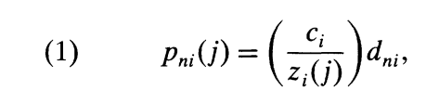
- Which is the unit production cost multiplied by the geographic barrier
- We assume perfect competition so p_{ni} (j) is what buyers in country n would pay if they chose to buy good j from country i
- But shopping around the world for best deal the price they actually pay for good j will be p_{n} (j) the lowest across all sources i:
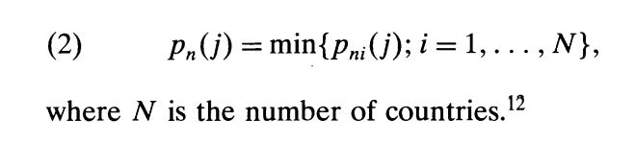
- Given these prices, buyers (who could be final consumers or firms buying intermediate inputs) purchase individual goods in amounts Q(j) to maximize a CES (constant elasticity of substitution; flexible way to say substitutes for each other but not perfect) objective
- A buyer’s utility is from consuming quantities Q(j) of a continuum of goods j ∈ [0,1] combined according to this formula rather than adding up linearly
- So sigma is the elasticity of substitution here and is >0 between any two goods; how willing person is to sub one good for other as relative prices change; higher sigma means more elastic
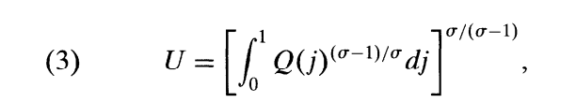
- This maximization is subject to a budget constraint that aggregates across buyers in country n, to X_{n} , country n’s total spending

Technology
- Recall that country i's efficiency at producing good j is z_{i} (j) for each good
- Now they treat efficiency as random; efficiency at each good is drawn randomly from a probability distribution
- Z_{i} is the random variable representing country i's efficiency (productivity lottery specific to country i)
- Each good j gets its own independent draw from this distribution so good 1 might be high efficiency good 2 low etc.
- F_{i} (z) = P(Z_{i} <= z) is the cdf of country i's efficiency the prob that a random draw of efficiency for country i is at or below some value z
- Each country has its own distribution F_{i} ; some countries might be “shifte dup” so they have generally higher efficiency draws/better tech overall
- Since there’s a continuum of goods (infinitely many, indexed on [0,1]) the LLN implies that the randomness washes out in aggregate
- Even though each individual good’s efficiency draw is random, across whole continuum, the realized outcomes will match the theoretical probabilities exactly
- Probability = observed frequency
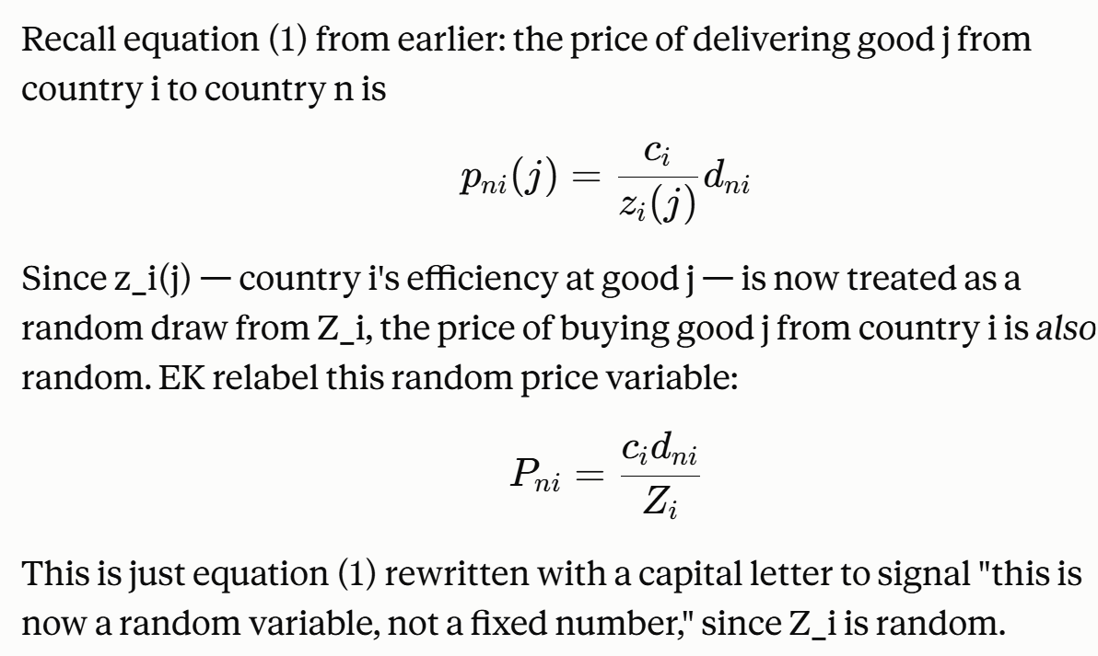
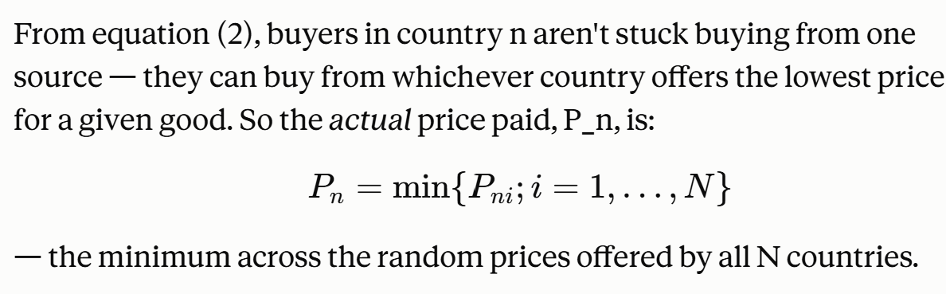
- For any given good, whichever country happens to have drawn the lowest P_{ni} wins the right to supply that good to country n
- Since P_{ni} is random, which country wins is also random but you can calculate the probability that country i is the winner
- EK call this probability pi_{ni} the likelihood that country i's price turns out to be the lowest for a given good in country n
- To get min of random variables use extreme value theory; which formula you use though depends on what distribution the underlying RVs follow
- EK choose to assume each country’s efficiency distribution F_{i} (z) is Frechet (or Type II extreme value):
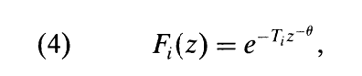
- T_{i} = the location parameter which is country-specific. Bigger T_{i} shifts whole distribution upward; meaning a high efficiency draw for any good is more likely
- It is a measure of a country’s general productivity level – its absolute advantage
- Theta is shape parameter; same across all countries; controls spread/variability within a country’s distribution; how much its efficiency varies from good to good
- Higher theta means less variability; efficiency draws cluster closer together across goods, so country is roughly similarly good or bad at everything
- Lower theta means more variability
- So tldr T is absolute advantage (how generally productive is country overall) and theta is comparative advantage strength (how much relative efficiency varies within a country across different goods)
- Has helpful property where min of several Frechet distributed RVs is itself Frechet distributed
- Use this to get clean expression for pi_{ni}

Prices
- Now discuss the distribution of prices implied by Frechet efficiency assumption
- Recall P_{ni} = c_{i} d_{ni} / Z_{i} the price country n would pay for a good produced in country i is inversely related to the random efficiency draw Z_{i}
- Since we know the distribution of Z_{i} , equation 4 Frechet, can derive distribution of P_{ni} through a simple substitution
- This gives:
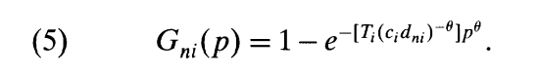
- This translates the randomness in efficiency into randomness in the price that country i would charge to deliver a good to country n
- The price actually paid, the min across all sources, P_{n,} will be below some level p unless every single source’s price is above p (i.e., all N countries fail to beat p) this gives:
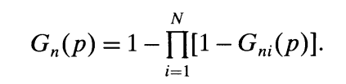
- Because of the properties of Frechet distribution (closed under minimization) this product simplifies into another Frechet-form expression:
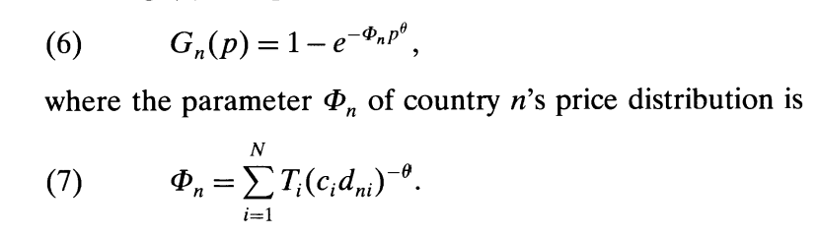
- Phi is a single number summarizing how favourable the overall price environment is in country n
- A higher phi means lower prices overall in country n (more competition, more access to cheap sources)
- It’s the sum across every country’s contribution to n’s price environment
- Each country i contrinbutes a term Ti(cidni)^-theta – high tech Ti, low input costs ci, or low trade barriers dni, all raise a country’s contribution to phi which lowers prices in n
- Edge cases
- Zero gravity world: all dni=1, no trade costs; phi becomes identical across all countries n; everyone has equal access to same global pool of tech
- Autarky: dni approaches infinity for all foreign sources; phi collapses to just Tncn^neg theta; country n’s own tech downweighted by its own input cost
- Three useful properties from the price distributions:
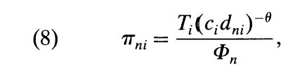
- This is country i's contribution to phi divided by total phi; gives prob that country i is the cheapest source for a given good sold in n – and (again via LLN over continuum of goods) it’s also the fraction of goods that country n buys from country i
- Second property: prices of goods actually purchased don’t depend on source: distribution of the price paid is still Gn(p)
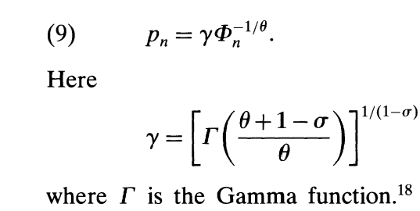
- This is the CES price index; recall consumers care about an aggregate price index p_{n} for the whole bundle of goods not just individual good-level prices
- Turns out this price index has a clean closed-form solution: it’s just a constant
- Means anything that raises phi (better tech access/lower costs/lower barriers) directly lowers overall price level in country n
- This equation lets EK later connect geographic barriers to deviations from purchasing power parity

Trade Flows and Gravity
- Can now link model to real trade data using that the price of goods actually purchased has same distribution regardless of source
- Since prices don’t systematically differ by source, country n’s average expenditure per good doesn’t vary by which country it came from – buying from country i costs, on avg, same as buying good from country k
- Because of this, the fraction of goods that country n buys from country i, which we derived as pi_{ni} , the prob that i offers the lowest price = it is also the fraction of country n’s total expenditure spent on goods from country i
- If prices per good were diff by source this wouldn’t hold
- So fraction of goods bought = fraction of money spent
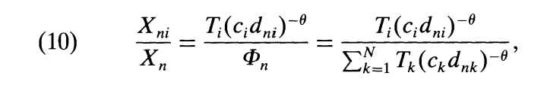
- Where X_{n} is country n’s total spending of which X_{ni} is spent on goods from i (including shipper cost)
- This resembles a gravity equation i.e., that bilateral trade flows relate to size of importer and exporter economies and to distance/barriers between them
- This needs to be cleaned up i.e., no T or c (tech and input cost) and it is expressed as a share instead of a level
- To get closer to classic gravity form, EK note that the exporter’s total worldwide sales, Q_{i} , (summing exports to all destinations including domestic sales) can be written by applying 10 to every possible destination m and summing:
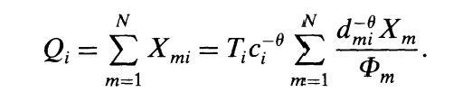
- The term Tc^theta is country i's raw competitiveness (tech relative to cost) is common to every destination so factors outside the sum over m
- EK then solve this Qi expression for Tici^theta and sub that back into equation 10, also using the price-index formula equation 9 to replace phi with something expressed via pn
- After this substitution, T, c, and phi all disappear from the formula, replaced by Qi and price indices pn, pm – quantities that are at least conceptually observable
- The result is equation 11:
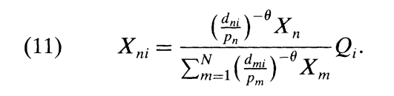
- Matters cuz equation 10 is expressed in terms of unobservable structural parameters (T, c, phi)
- Equation 11 re-expresses the relationship using observable in principle quantities; total sales, total spending, price levels, and trade costs
- So it looks like something you could actually estimate and is now close to the standard gravity equation’s functional form
- Interpreting equation 11:
- Qi = exporters total sales with unit elasticity; a country that produces twice as much sells (all else equal) twice as much to every destination
- Xn = importer’s total spending also enters with unit elasticity; country that spends twice as much buys twice as much from every source
- Look closely at the term ${\left(d_{mi}/p_{m}\right)}^{-θ}$(dmi​/pm​)−θ. The geographic barrier from i to any market m, d_mi, is divided by that market's own price level p_m. The intuition: if market m already has low prices (p_m is low, meaning fierce local competition or lots of cheap suppliers already there), it's harder for country i to break in and compete — this has the same discouraging effect as if the physical geographic barrier to m were higher. A cheap, competitive market and a distant, costly-to-reach market both make it hard for i to sell there. So EK bundle these two forces together into a single "effective barrier," and interpret $\left(d_{mi}/p_{m})^{-θ}X_{m}\right.$(dmi​/pm​)−θXm​ as "the market size of destination m, as perceived by country i" — a market is attractive to i only if it's both large (high X_m) and not already saturated with cheap local competition (high p_m, meaning low competition).
- Summing this perceived-market-size term across every possible destination m gives the denominator of (11) — the total world market as seen from country i's perspective, adjusting every market's raw size for how accessible it actually is to i. Then X_ni (relative to Q_i) is simply n's share of i's effective world market: how big a slice of i's (accessibility-adjusted) global opportunities does market n represent
Calibration of Model
- A plain gravity regression just tells you trade correlates with size and distance — it doesn't tell you why, or let you predict what happens under a policy change
- EK's model, in contrast, decomposes trade flows into the deeper parameters (Tᵢ, θ, trade costs) that cause that gravity pattern
- Only by identifying those underlying structural parameters can you run counterfactuals — a bare-bones statistical gravity equation can't do that on its ow
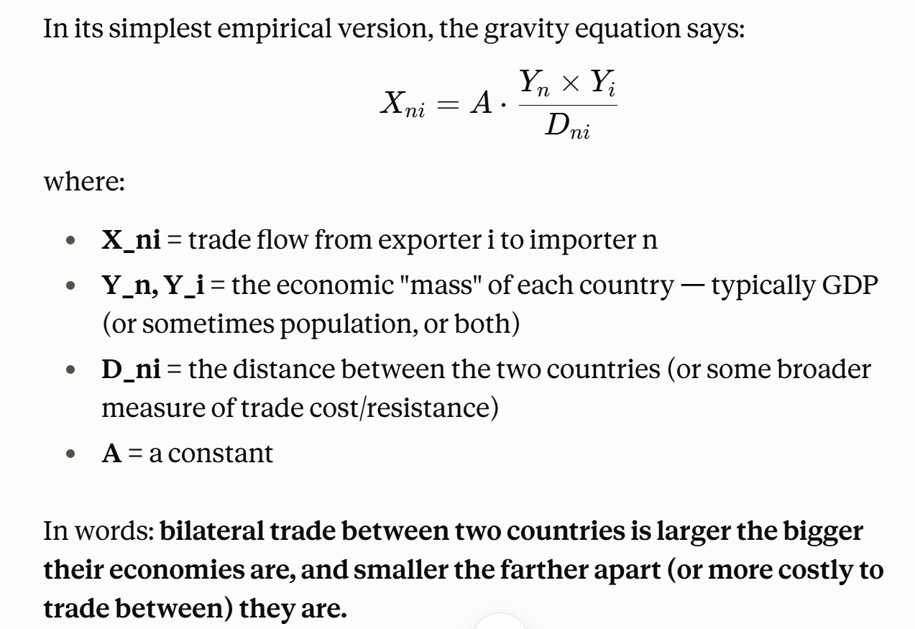

Implementation of Model
- How manufacturing fits into larger economy
- Manufacturing lab income in country i is labour’s share of country i's manufacturing exports around the world, including sales at home:
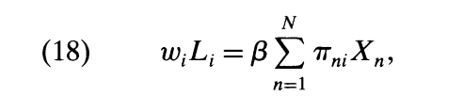
- L is manufacturing workers and X_{n} is total spending on manufactures
- Denote aggregate final expenditures as Y_{n} with alpha the fraction spent on manufactures
- Total manufacturing expenditures are then:
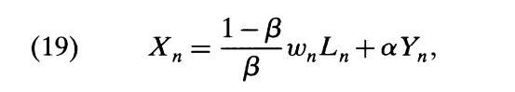
- Where the first term captures demand for manufactures as intermediates by manufacturing sector itself
- Yn final expenditure consists of value-added in manufacturing Y_{n}^{M} = w_{n} L_{n} plus income generated in nonmanufacturing Y_{n}^{O}
- We assume that at least some of nonmanufacturing output can be traded costlessly, and use it as our numeraire

- elf. Final expenditure Yn consists of value-added in man- ufacturing

Results
- Model’s trade-share equation, once aggregated up to actual trade volumes (not just shares) predicts that:
- Trade btwn countries rises with their economic size (GDP) and falls with distance/trade costs classic empirical gravity pattern

- Section 6.1, 6.3
- gravity equation (probability/trade-share formula)
- how wages, trade cost, productivity enter it

Assignment
- Simplest version of the EK model augmented to have trade imbalances
- Multiple countries: no change
- Single Sector
- Section 4.4
- Sector manufacturing only so
- Alpha = 1
- Y_{i} = w_{i} L_{i}
- Wage must adjust to maintain trade balance
- Real GDP per worker (welfare measure) is then:
- W_{i} = (Y_{i} /L_{i} )/p = w_{i} /p
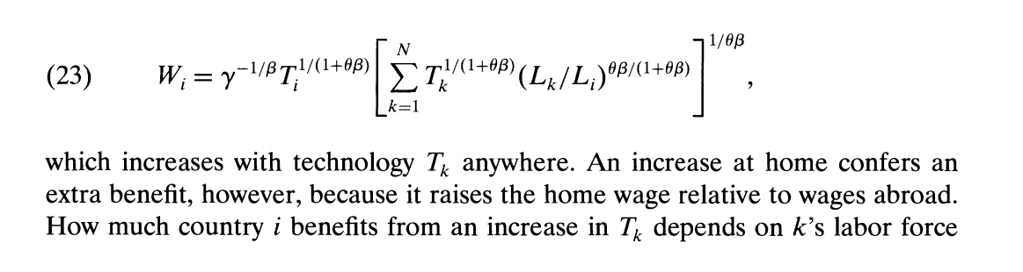
- Production functions that use only labor
- Section 4.1
- They assume production combines labour and intermediate inputs with labour constant share B
- Intermediates comprise full set of goods according to CES aggregator (3)
- The overall price index in country i, p_{i} , given by equation 9, becomes the appropriate index of intermediate goods prices there
- Cost of an input bundle in country i is thus:
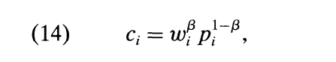
- Where w_{i} is wage in country i
- Because intermediates are used in production, c_{i} depends on prices in country i, and henc on phi
- But through equation 7, the price parameter phi depends on input costs everywhere
- Let B=1 for no intermediates then equation 14 becomes:
- c_{i} = w_{i}
- So input cost is just the wage; intermediates get zero weight
- Equation 7 simplifies
- Equation 16
- Yn = wnLn
- Xn = wnLn

